**VISUALIZATIONS**

**TEJASREE.PETA**

**AP20110010459**

1. **MOOD DISTRIBUTION:** From the mood distribution analysis, we can observe the following: Frequency of Each Mood: We can see the count or frequency of each mood category, such as "Happy", "Sad", "Neutral", "Angry", "Lonely", and "Rad", recorded in the dataset. This provides an overview of the overall distribution of moods and the prevalence of each mood category.

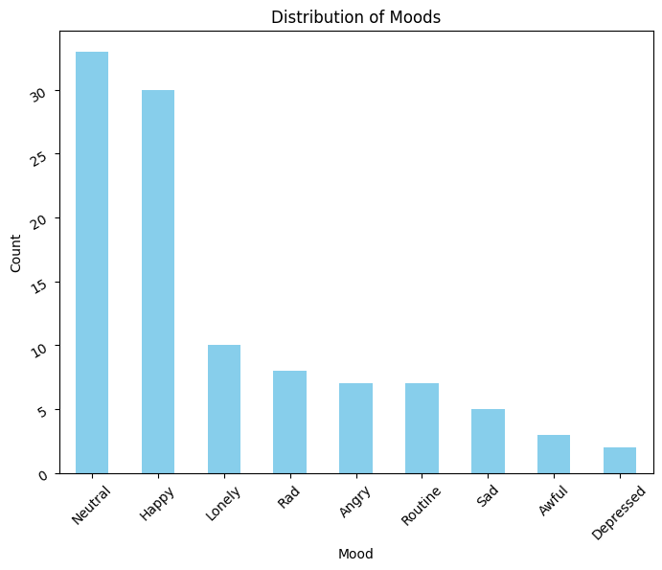

1. **ACTIVITY DISTRIBUTION:** From the activity distribution analysis, we can observe the following: Frequency of Each Activity: We can see the count or frequency of each activity category, such as "Work", "Leisure", "Relationships", "Routine", "Events", "Health", "Finance", "Self-Improvement", and others, recorded in the dataset. This provides an overview of the overall distribution of activities and the prevalence of each activity category.

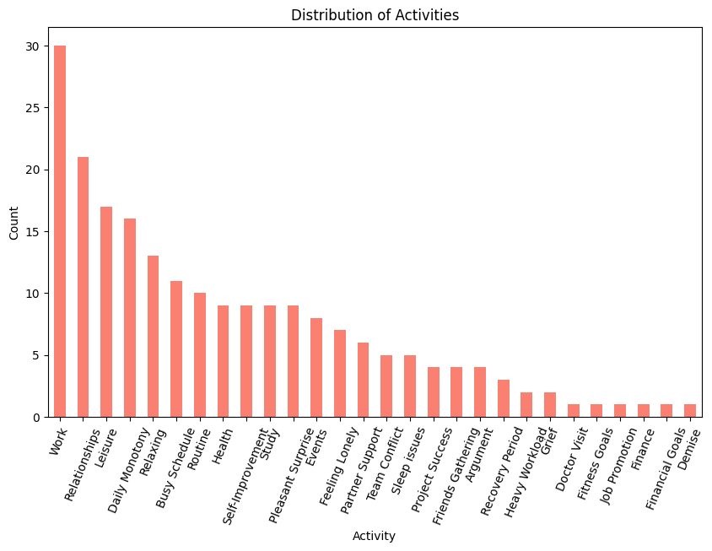

**ACTIVITY-1:**

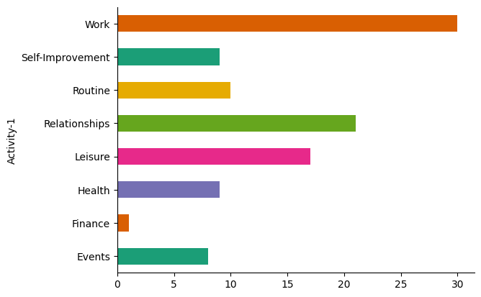

**ACTIVITY-2:**

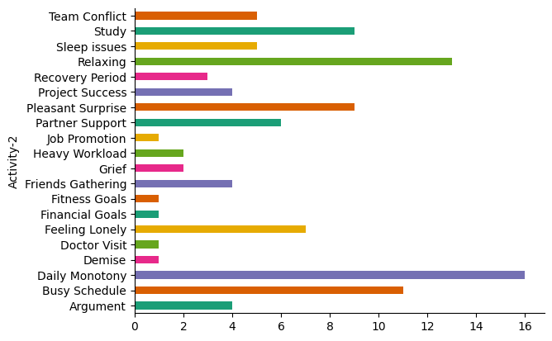

1. **DISTRIBUTION OF MOODS BY DAY:**

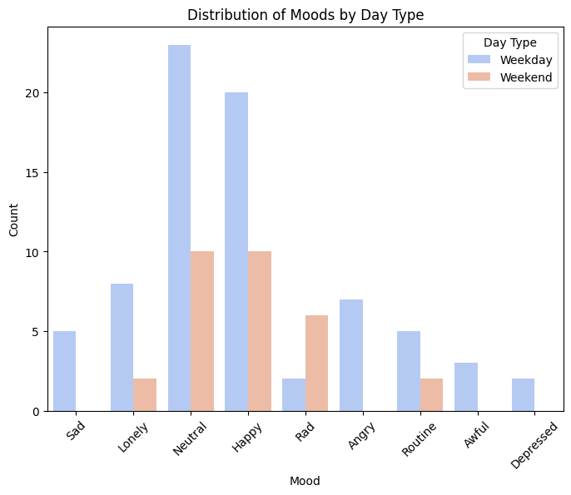

1. **BOX-PLOT:**

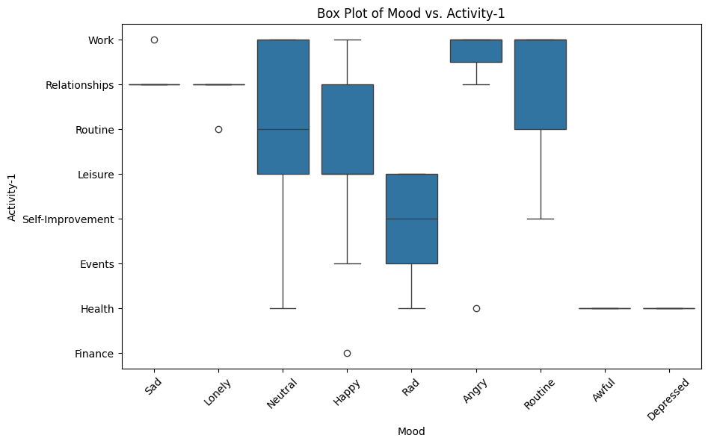

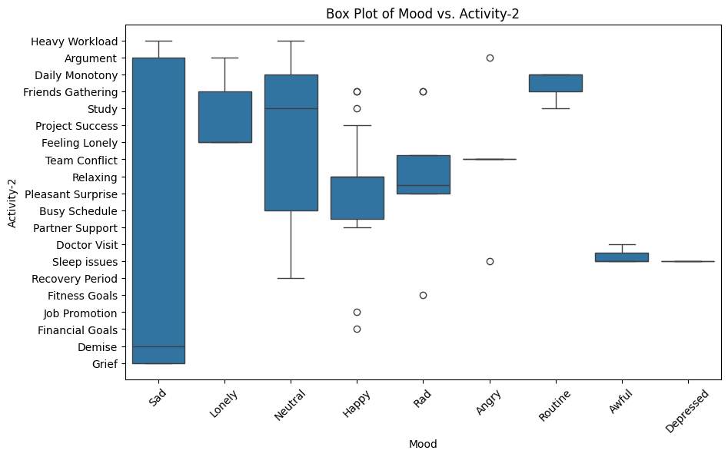

1. **TREND ANALYSIS:** We'll start by visualizing trends over time for moods and activities. This will help us identify any patterns or recurring themes. We can plot the frequency of each mood and activity over the days of the week.

**ACTIVITY-1:**

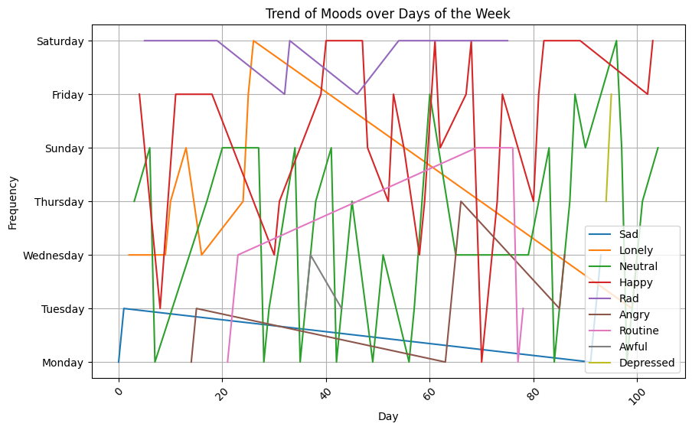

**ACTIVITY-2:**

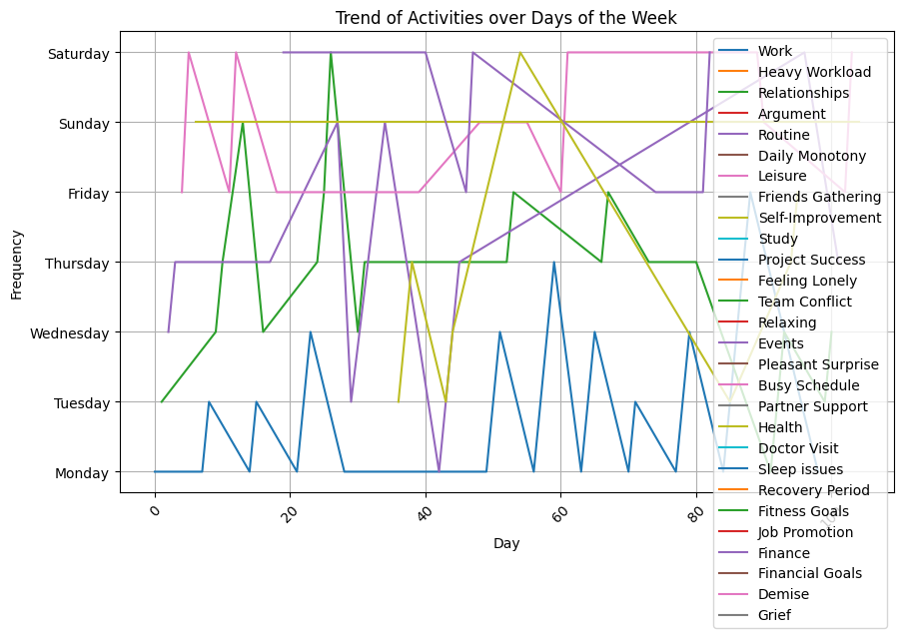

1. **CO-RELATION ANALYSIS:**

**DAY VS ACTIVITY-1:**

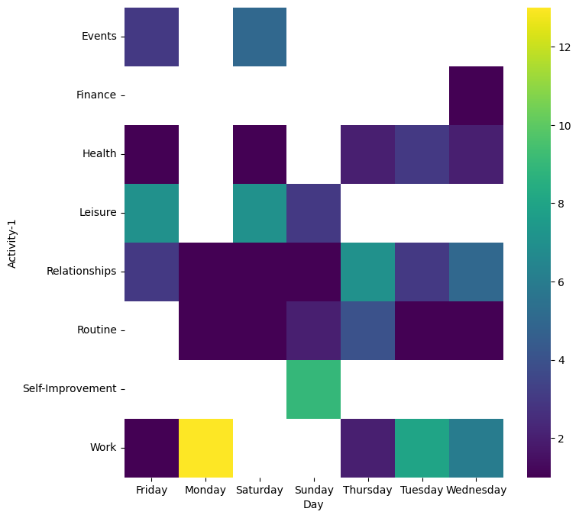

**DAY VS ACTIVITY-2:**

